1. Core Question (5%, around 250 words)
How does good HCI design improve user satisfaction for the "Smile & Sunshine Toy System" and what advantages does it bring?
HCI (Human-Computer Interaction) design focuses on three key points: usability, ease of learning, and enjoyment. For the Smile & Sunshine Toy System, good HCI design makes a big difference to users. First, it helps customers finish ordering toys or asking for quotes faster. Clear navigation (like a consistent top menu) lets users find what they need easily, whether on phones or computers. Second, it reduces mistakes—form checks stop wrong info (like missing phone numbers) and give quick feedback with pop-up animations or status tips. Third, it builds trust: showing clear prices, stock levels, and delivery status makes users feel safe.
These improvements bring great advantages. Customers are less likely to leave the website halfway, so more people complete purchases. Fewer operation errors mean less work for customer service teams. Staff also benefit from user-friendly backend tools, which make processing orders and quotes quicker. Happy users will buy again and recommend the system to others, helping the company get more repeat customers and a good reputation. In short, good HCI design turns a simple toy sales system into a satisfying experience for everyone.
2. User Analysis (15%)
User Characteristics
- Target Groups:
  - Parents and gift buyers (people who buy toys for kids or friends’ children)
  - Toy lovers (collectors or hobbyists who like unique or customized toys)
  - B2B buyers (businesses that order toys in bulk or need custom designs for resale)
  - Internal staff (employees who handle quotes, shipments, and stock refills)
- Key Differences:
  - Digital skills: Some parents may not be good at using online tools, while toy lovers and B2B buyers are more familiar with apps/websites.
  - Devices: Parents often use phones to shop in free time; B2B buyers and staff prefer computers for bulk orders or backend work.
  - Motivations: Parents care about price and safety; toy lovers focus on unique designs; B2B buyers want low bulk prices; staff need efficient tools to save time.
Techniques for Observing and Listening to Users
- Usability Testing: Ask users to try the toy ordering and quote request processes. Record how long they take and what mistakes they make (e.g., can’t find the "customize" button).
- Semi-Structured Interviews: Talk to users to learn their problems—like not knowing stock levels, unclear delivery times, or trouble explaining custom toy needs.
- Surveys: Ask users to rank their needs (1=most important): price transparency, stock visuals, delivery tracking, or pop-up feedback.
Environment Analysis
- Usage Scenarios:
  - Customers: Use phones to shop during short free time (e.g., commuting); use computers to compare toys or place bulk orders.
  - Staff: Use desktop computers in the office to process orders, create quotes, and check stock.
- Constraints:
  - Network issues (slow or unstable internet when using phones outside).
  - Different screen sizes (phones have small screens, so buttons need to be big enough).
  - Lighting and noise (users may shop in bright sunlight or busy places).
  - Time pressure (more orders during holidays, so users and staff need fast processes).
Recruiting Users
- Representative Samples: 5-8 parents, 3-5 toy lovers, 2-3 B2B buyers, 3-4 internal staff.
- Recruitment Channels: Invite existing customers via WeChat groups or emails; ask internal colleagues to join; offer small gift cards as a thank-you.
Task Analysis (HTA) – Toy Ordering Process (Individual Part 1)
- Main Task: Place an order for a toy
1.1 Log in to the customer account (enter registered email and password)
1.2 Browse toy listings (scroll or search for toys by category)
1.3 Add desired toys to the wishlist (click "add to wishlist" button)
1.4 Manage the wishlist
1.4.1 Review toy details (check price, stock, and features)
1.4.2 Modify order (change toy options or quantity)
1.5 Provide necessary information
1.5.1 Choose a payment method (e.g., credit card, online payment)
1.6 Confirm the order (click "submit order" button)
1.7 Receive order confirmation (view estimated delivery date)
1.8 Track order status (check updates like "processing" or "shipped")

- 任务分析（HTA，分两块举例）
- 玩具订购（个人负责部分 1）

To register: Click the "Create Account" button, then enter your Username, Email, Phone Number and Password to complete the registration.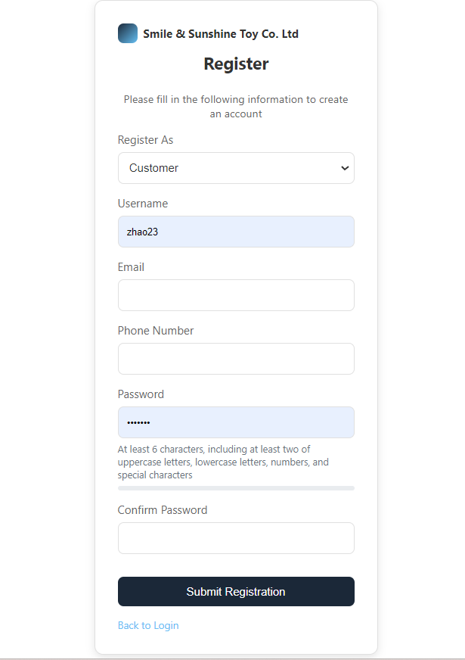
After logging into the customer portal, you can click on a product card to enter the product details page. From there, you can add the item to your wishlist, shopping cart, or favorites.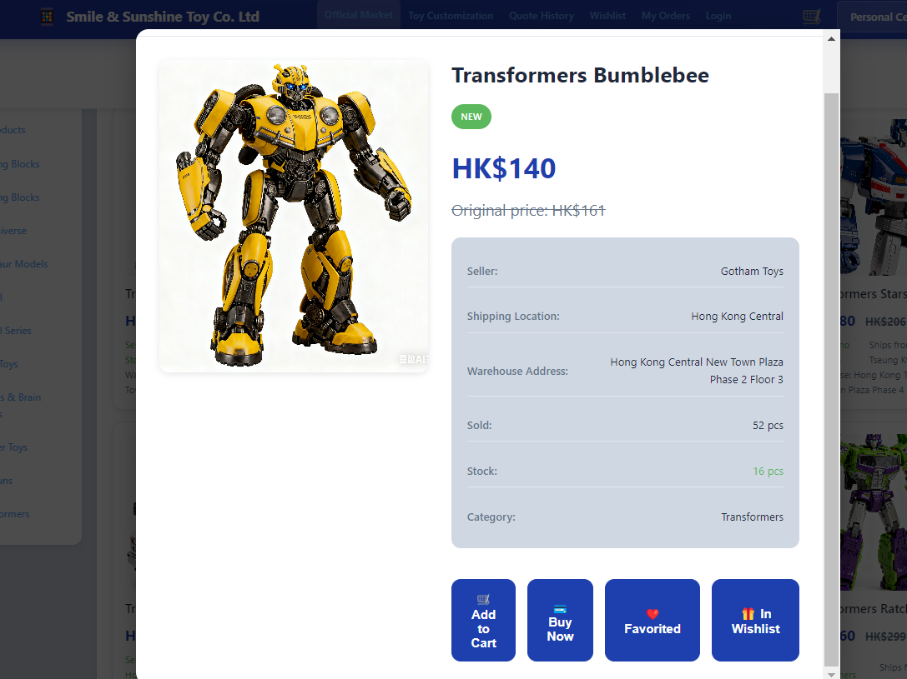

In your wishlist, you can view the toys you’ve added. You can directly click the button to navigate to the product payment page.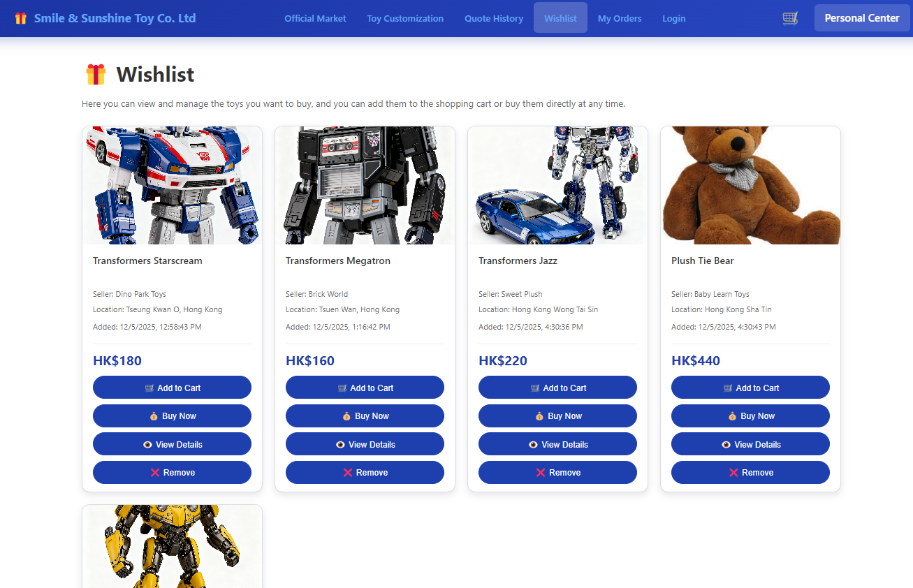

You can view the toys you like in your favorites.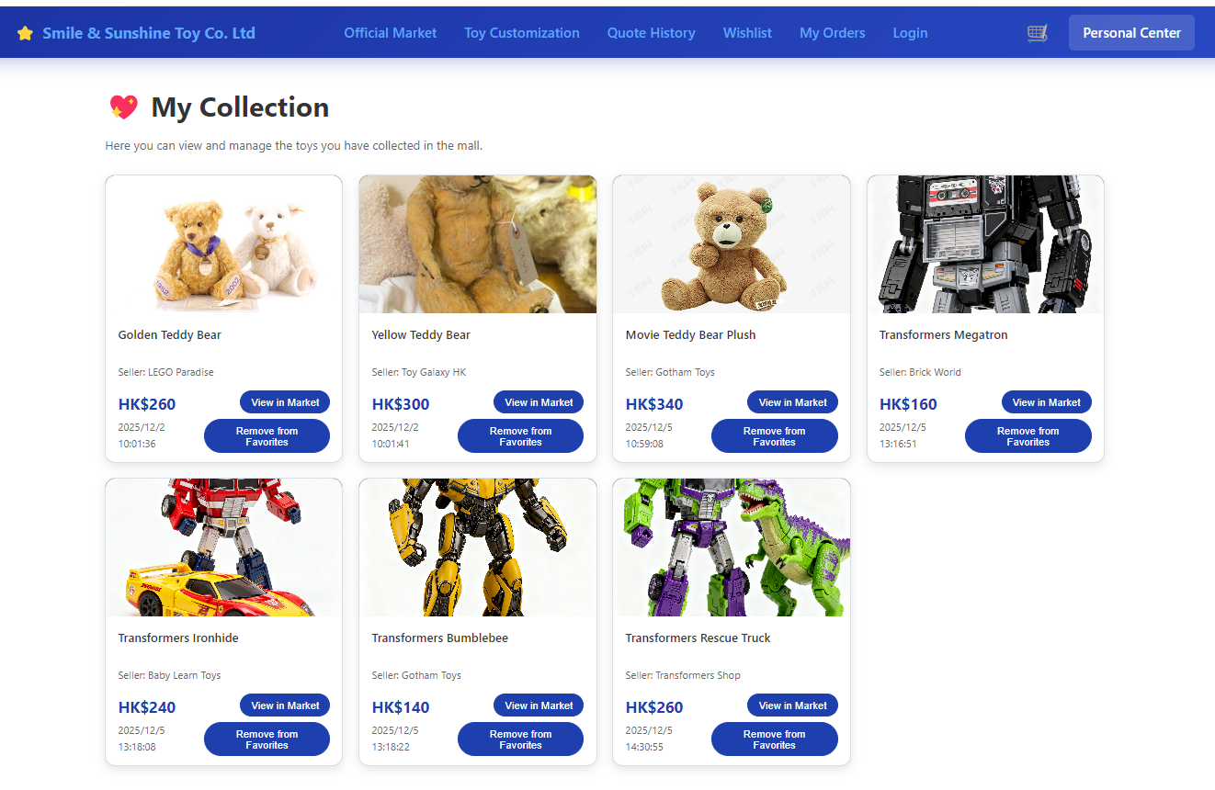
In the personal center, you can view and modify your personal information, such as your email address, phone number, and address.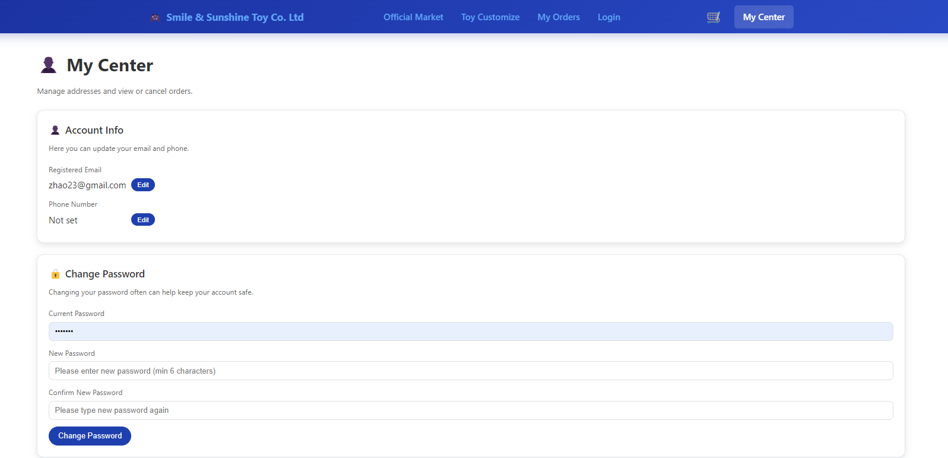

You can save your address and view your past shopping records.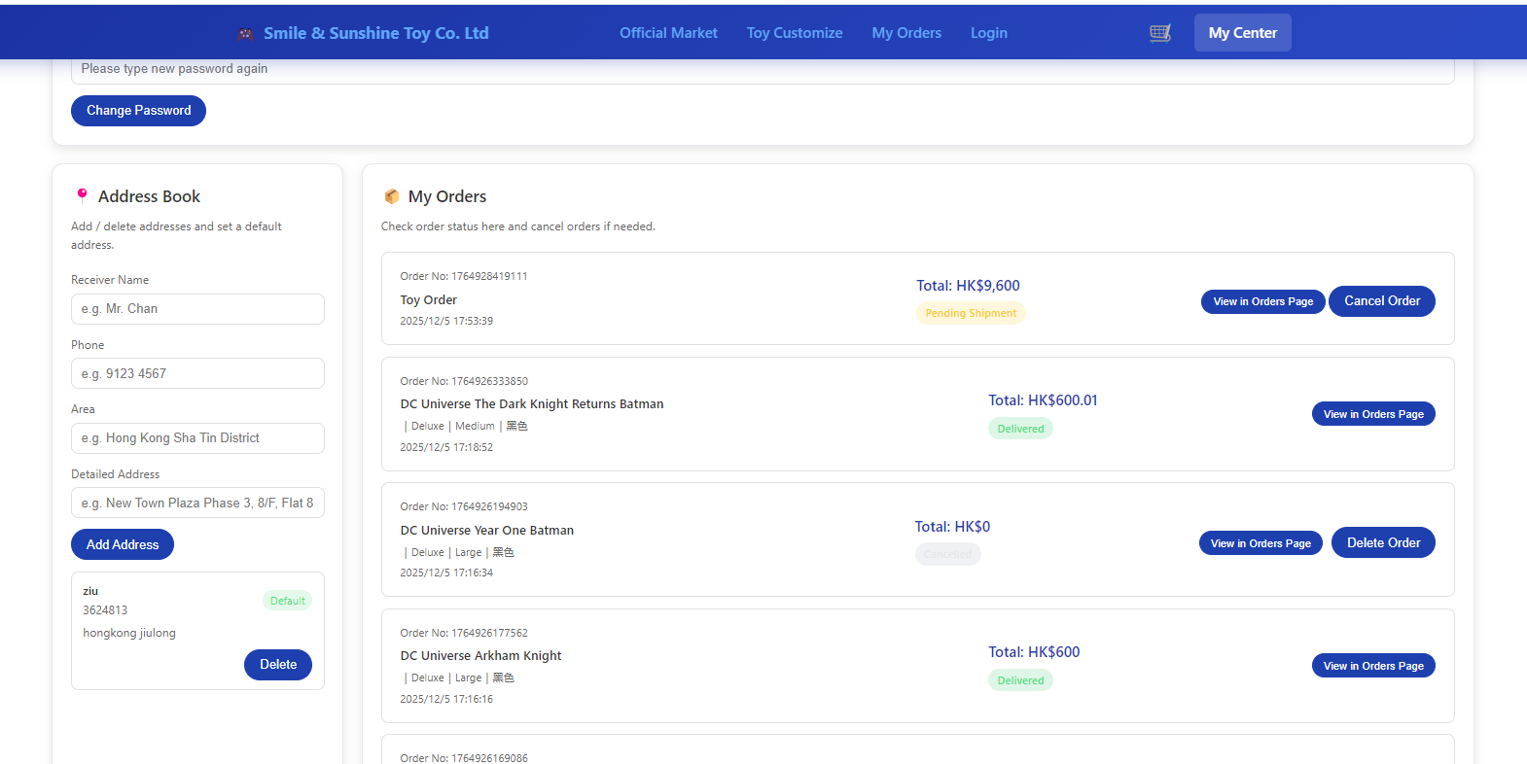

Browse/Search Products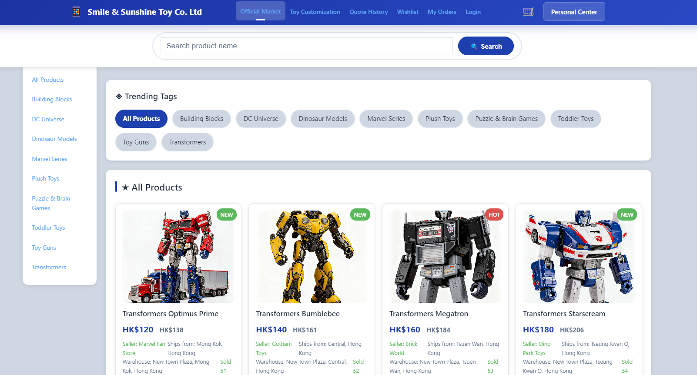
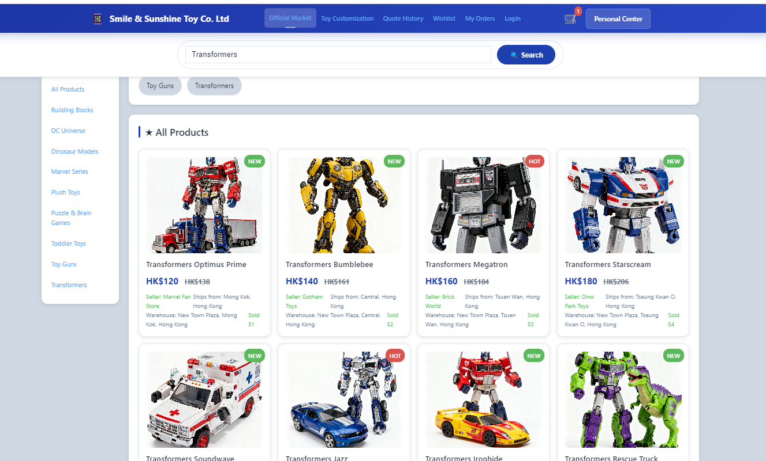

View Details/Stock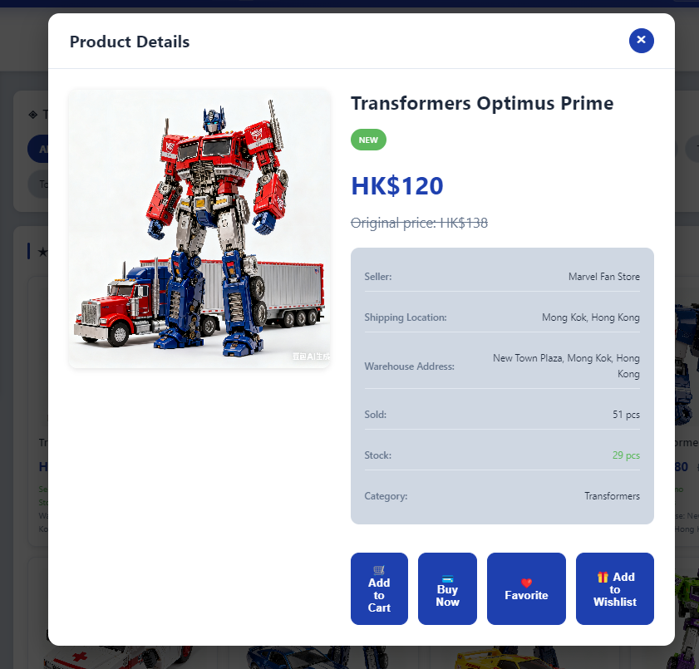

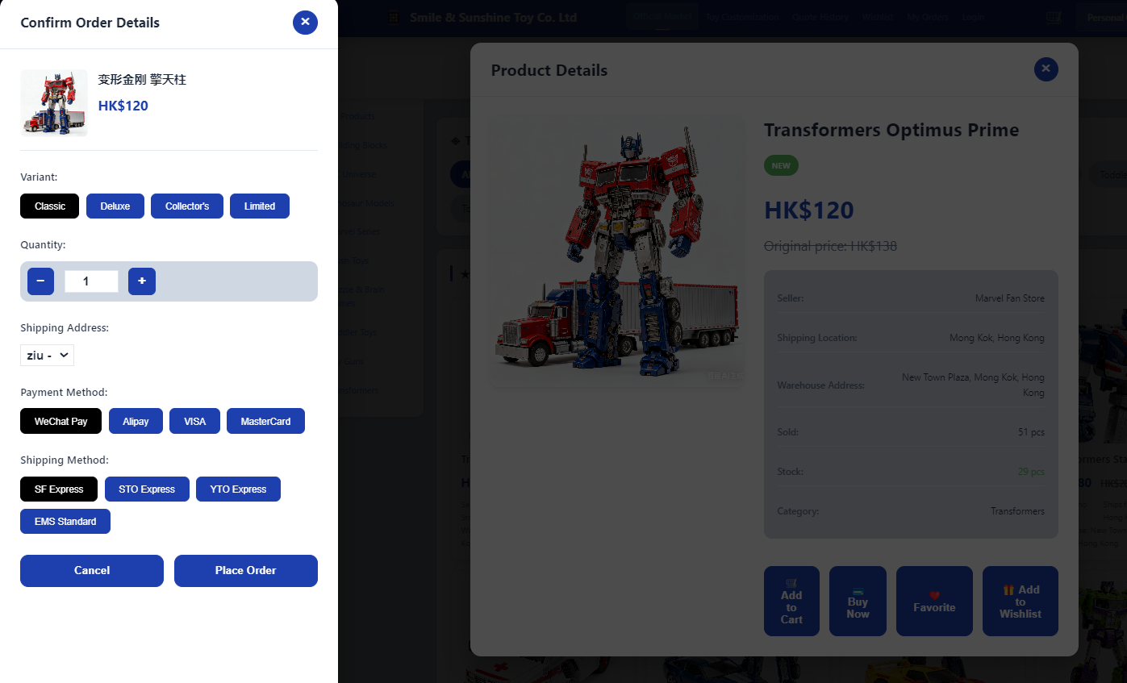
Checkout: Fill in Address / Make Payment

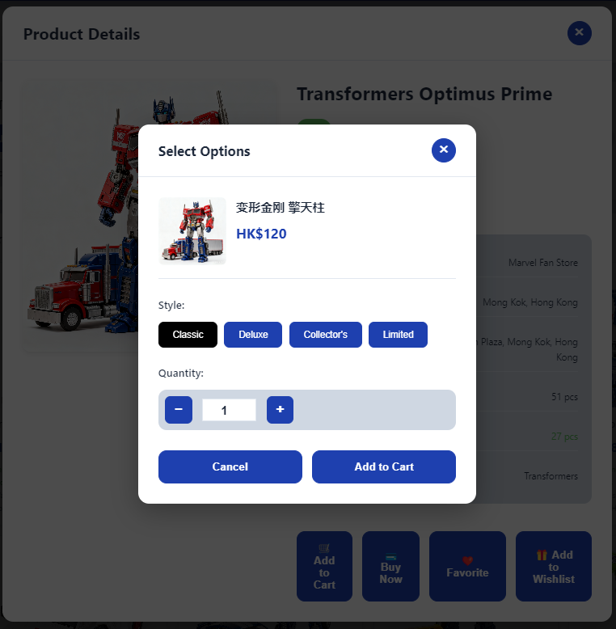
You can select products and add them to your shopping cart.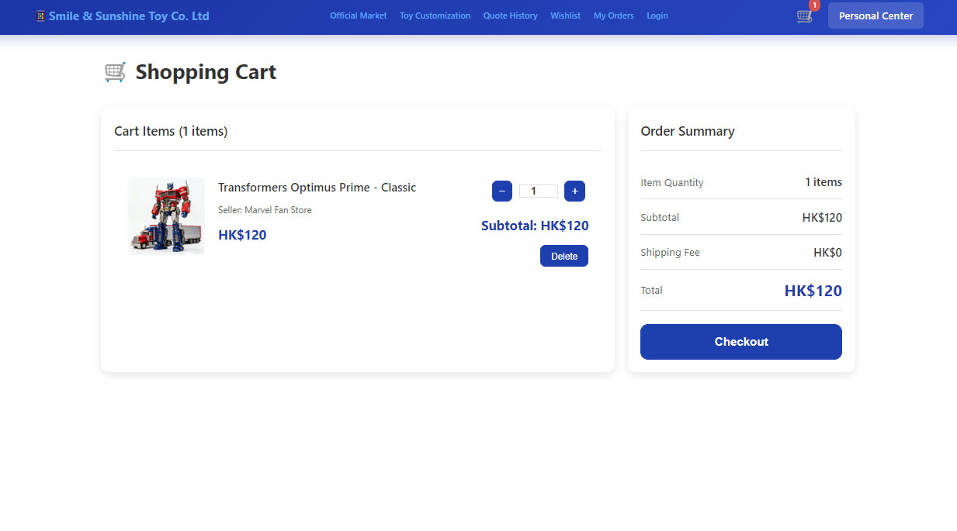
Items in the shopping cart can be checked out in bulk. 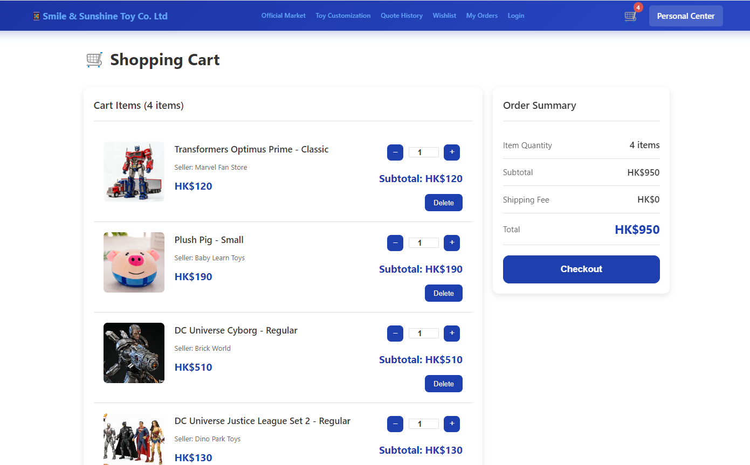
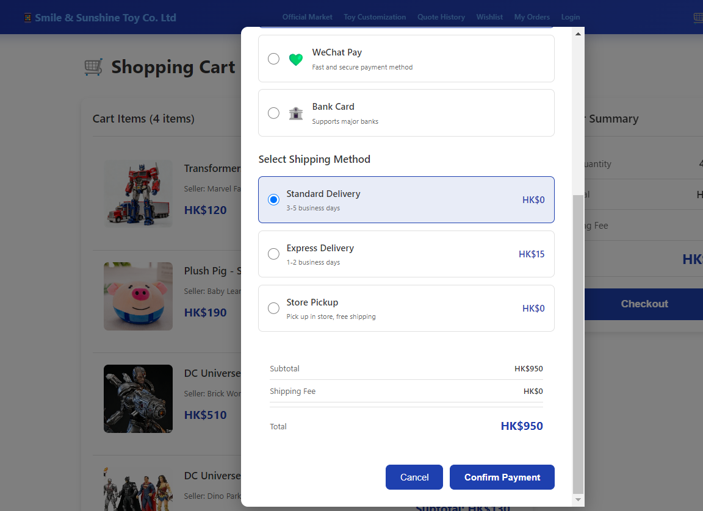
In My Orders, you can check the logistics status. After the order is shipped, you can receive the goods or initiate a return.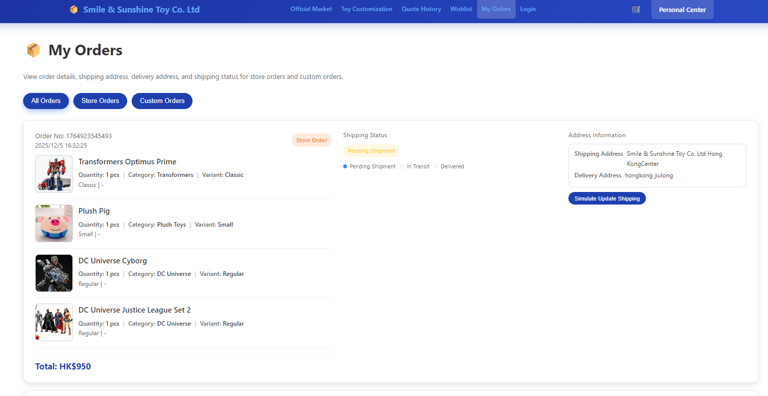

For delivered goods, you can confirm receipt by clicking the "Confirm Receipt" button.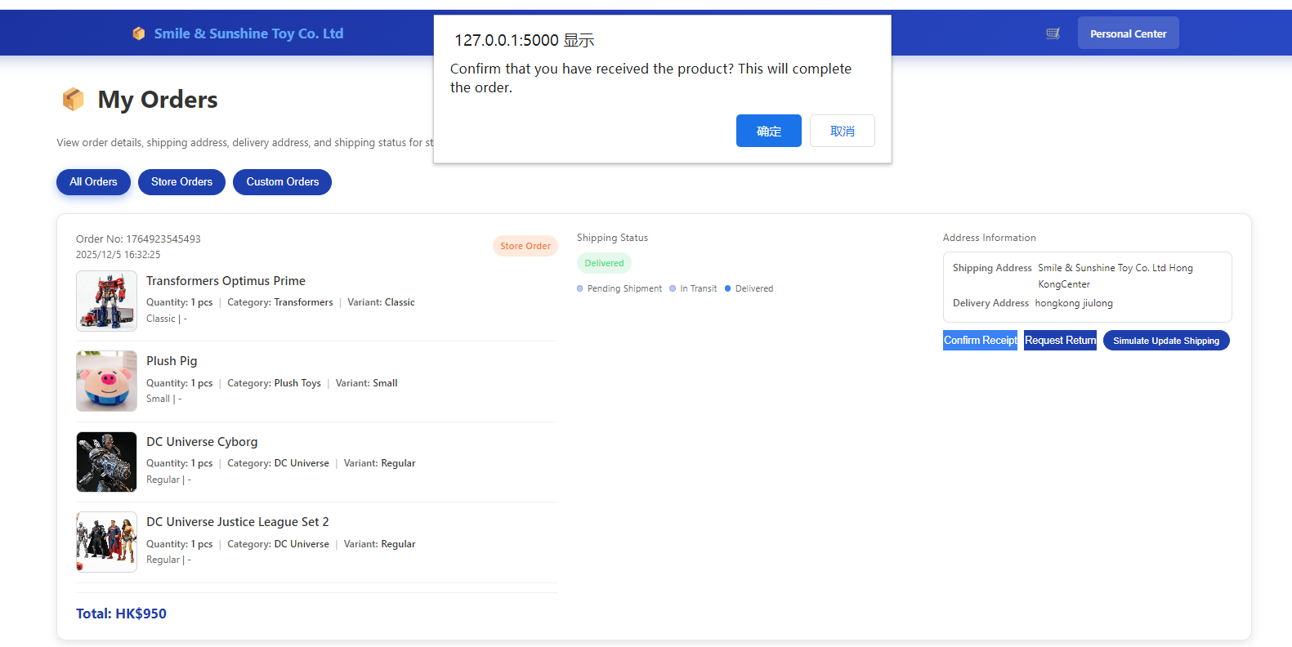
Even if the order shows "Confirmed Receipt", you can still select a reason to initiate a return.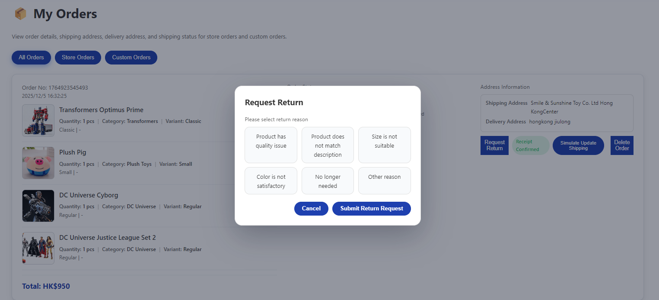
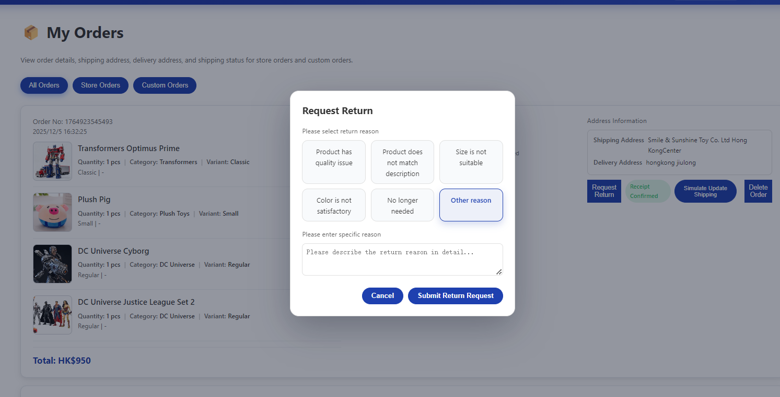
After initiating a return, you need to wait for the staff to review and approve your return request before proceeding with subsequent operations.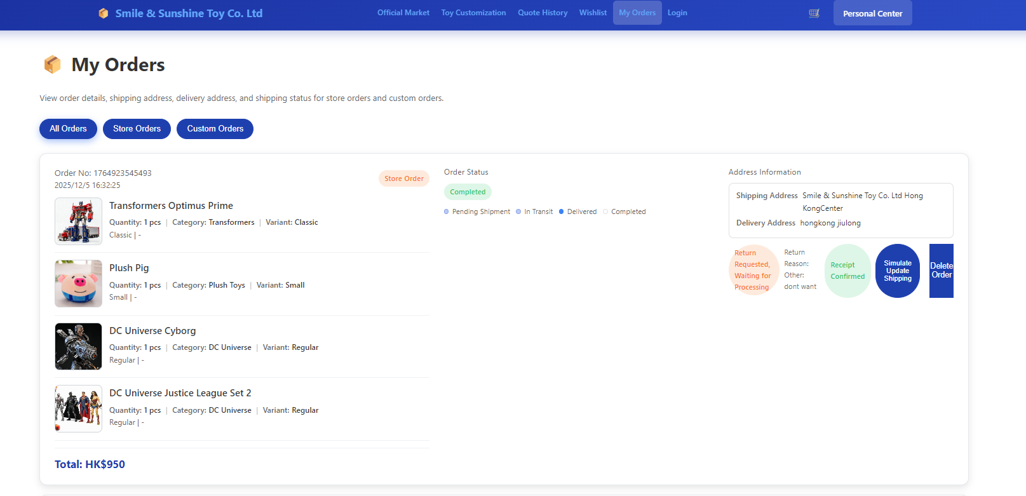

On the custom product page, you can use the search bar to find relevant products and select your preferred style.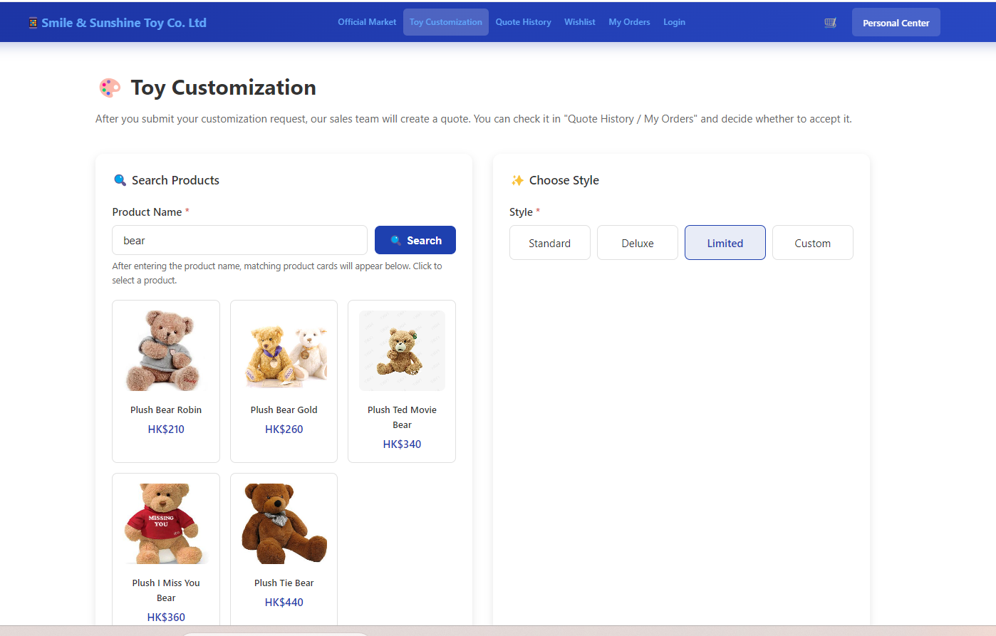
Enter your custom size and color. You can also input a custom color of your choice.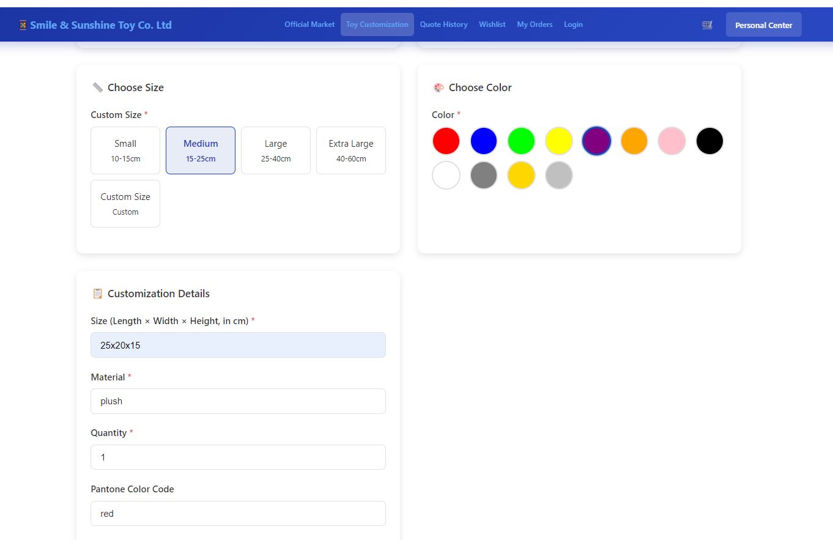
You can also input your customization requirements.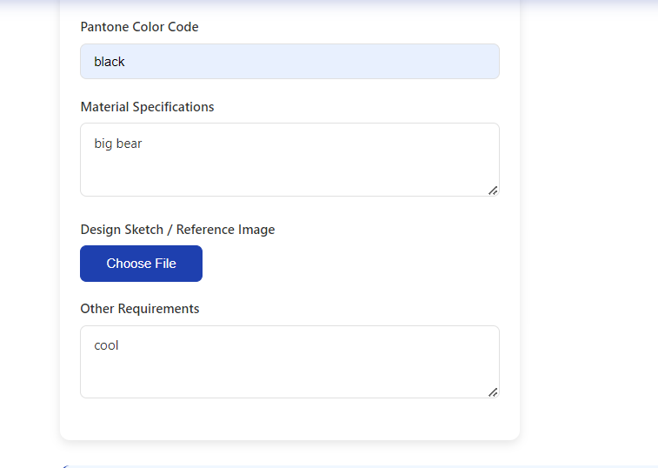
You can also select a local image as your design draft.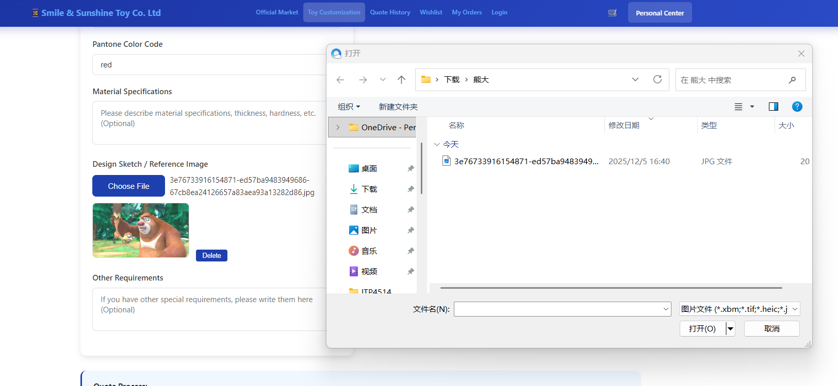
Click the "Submit Custom Order" button and wait for the staff to provide a quotation.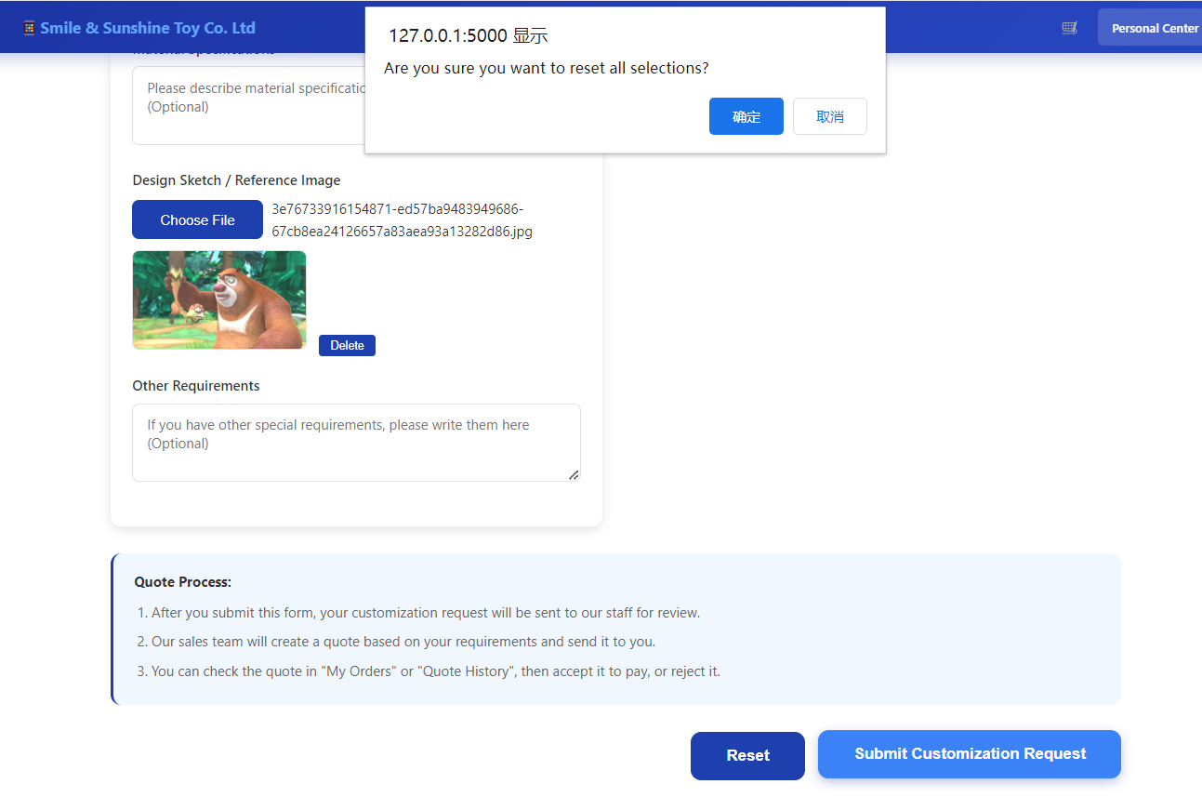

When the staff sends the quotation, you can click to view the quotation details, then accept or reject the quote.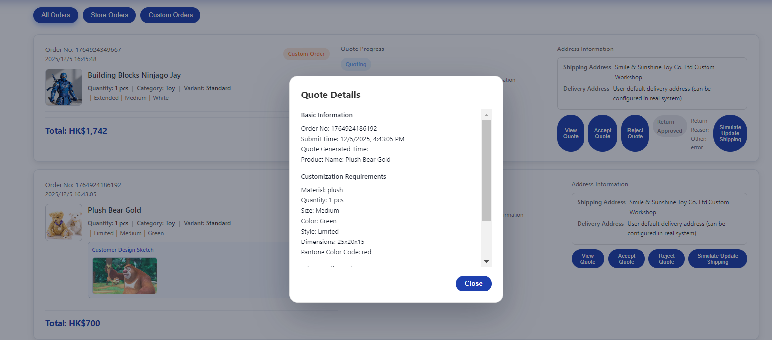
Once you accept the quotation, you can proceed to make the payment.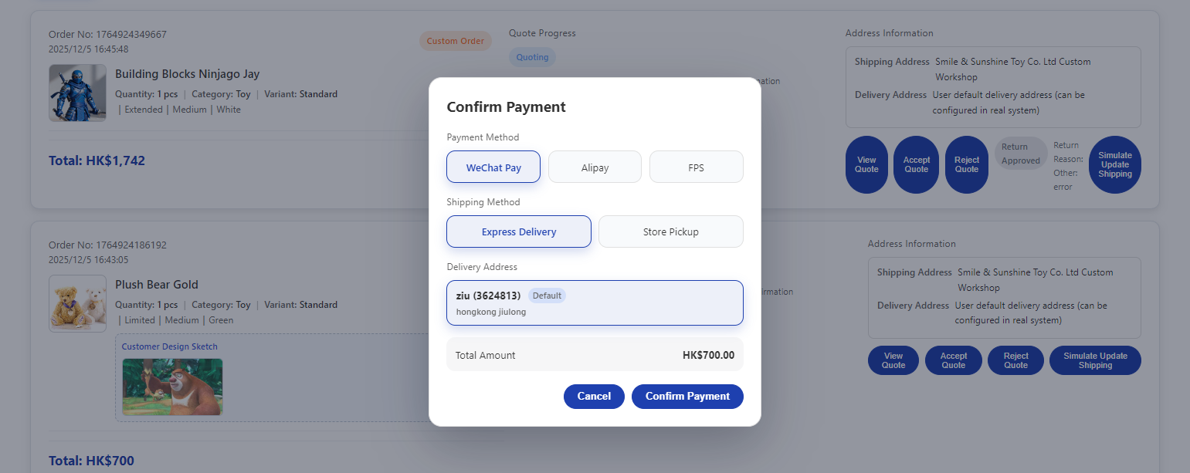
Once the goods are delivered, you can choose to confirm receipt or initiate a return!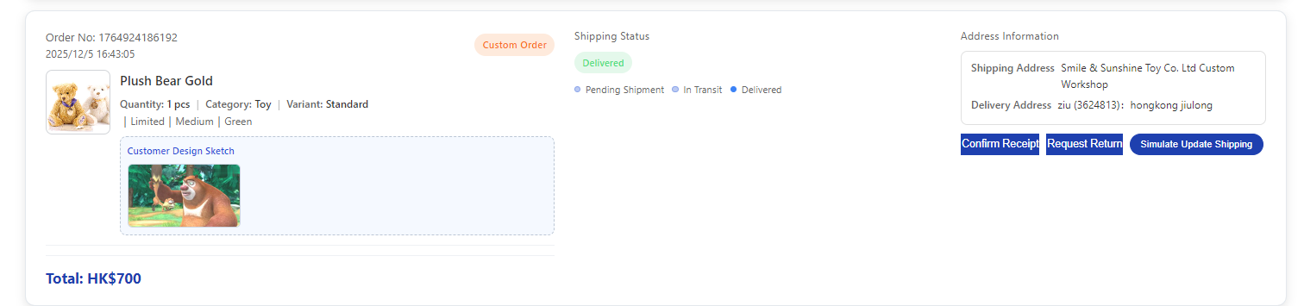

Staff Side: Click the "Create Account" button, enter your full name, phone number, email address and password, then click "Register" to complete the process.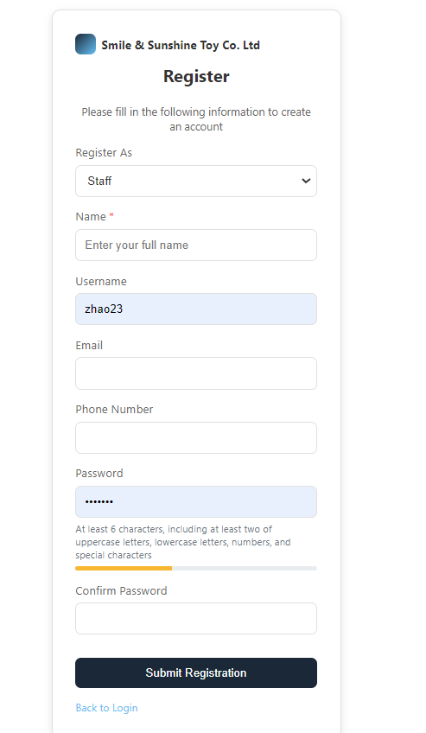
On the staff order management page, you can view the status of all customers' orders, such as Unshipped, In Transit, Return Requested, or Awaiting Quotation.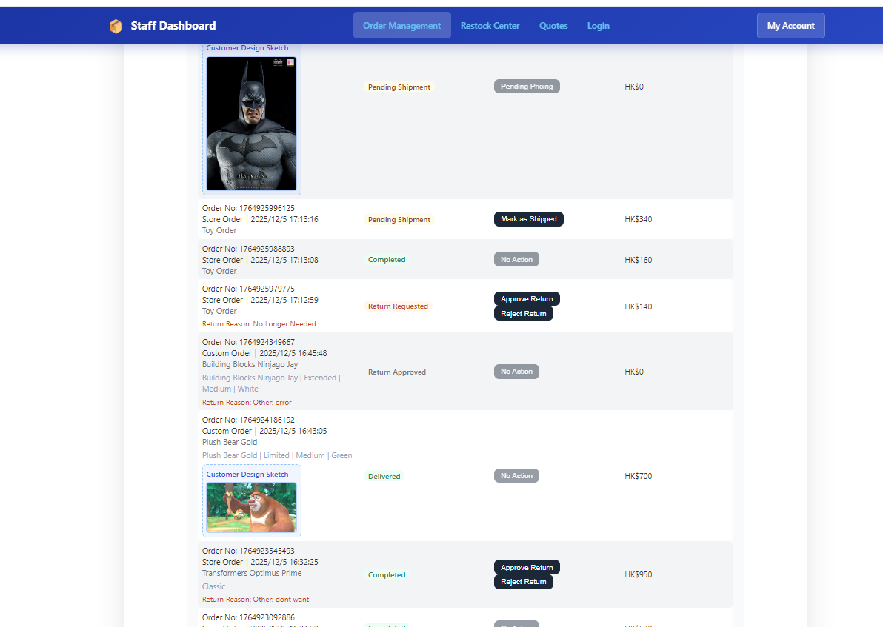

For return requests, staff can approve or reject the application. If rejecting the return, you must select and fill in the reason for rejection.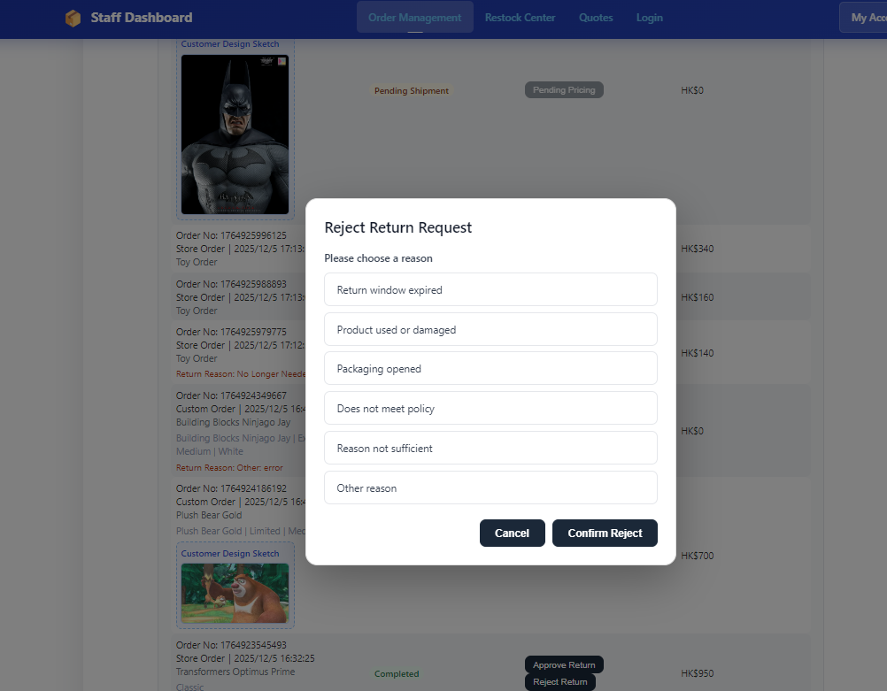
On the quotation page, you can view quotations that customers have accepted, rejected, or are still awaiting quotation.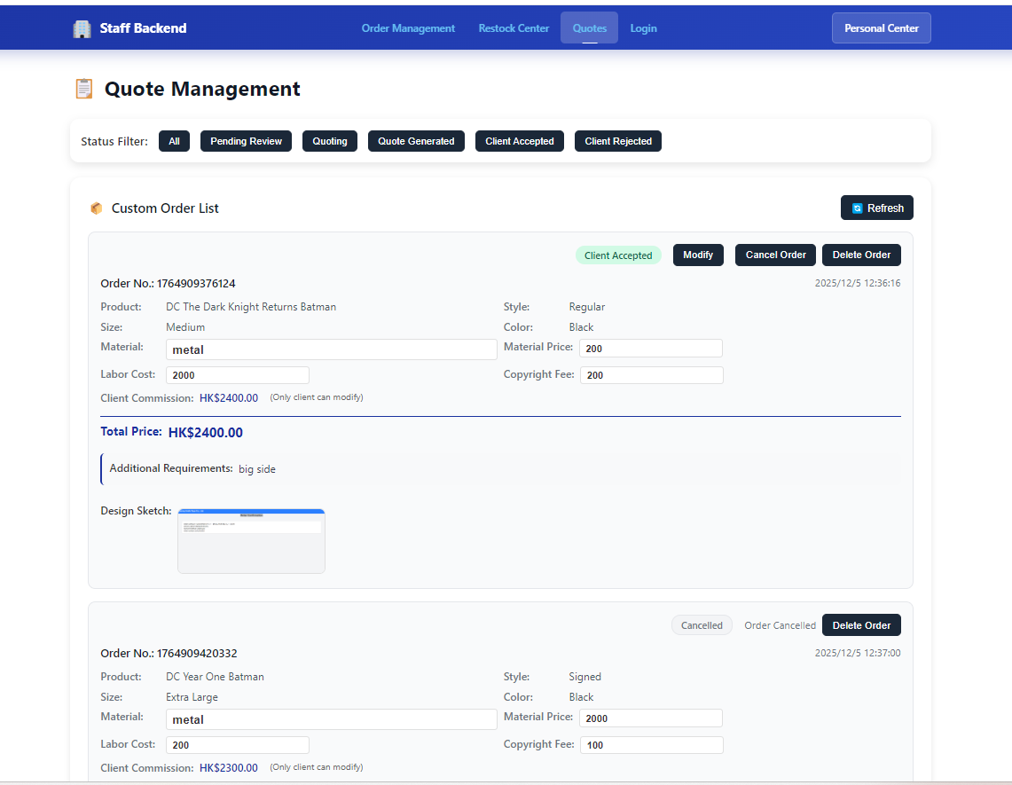
Click the "Pending Review" button to view orders awaiting quotation. You can click the input box to edit the price.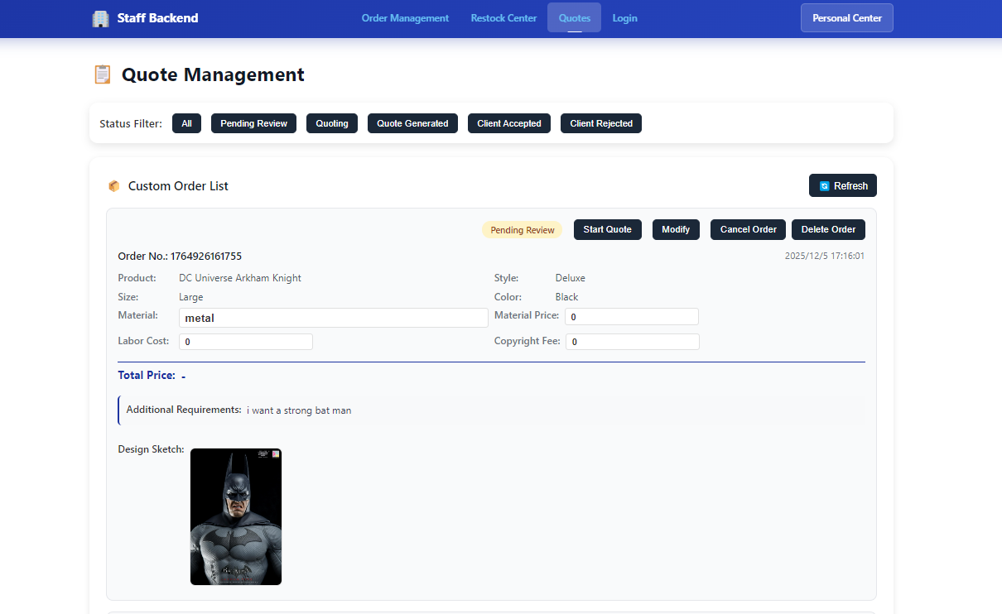
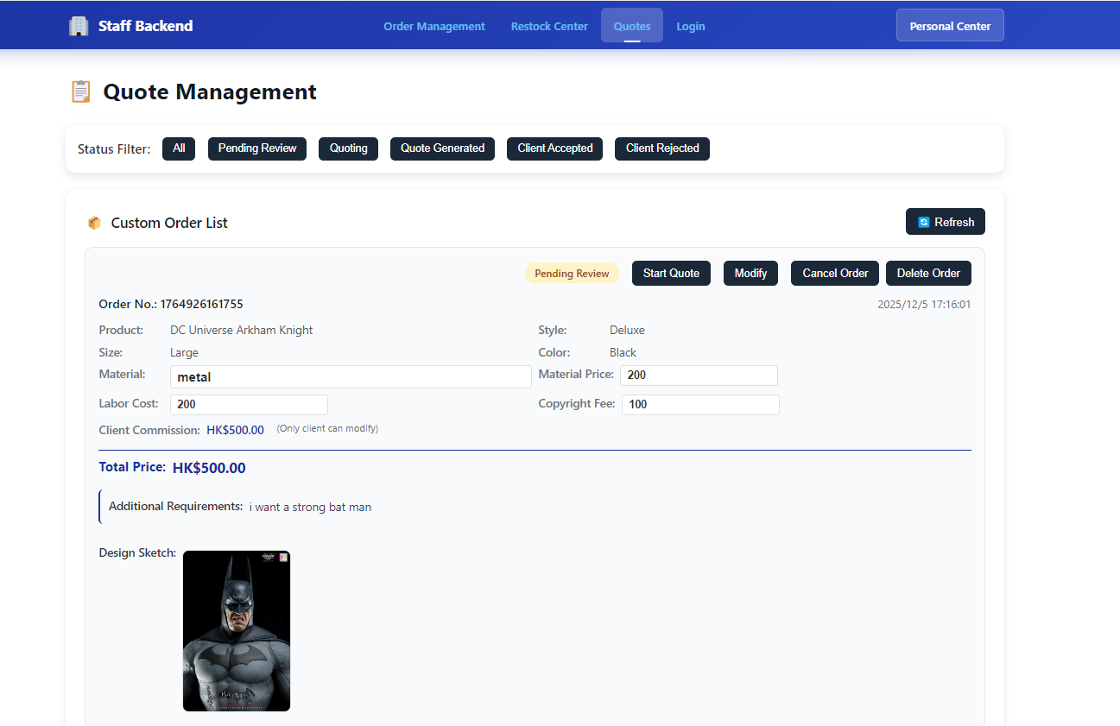
After entering the price, labor cost, and material cost, click the "Start Quote" button to submit the quotation and wait for the customer to confirm the price.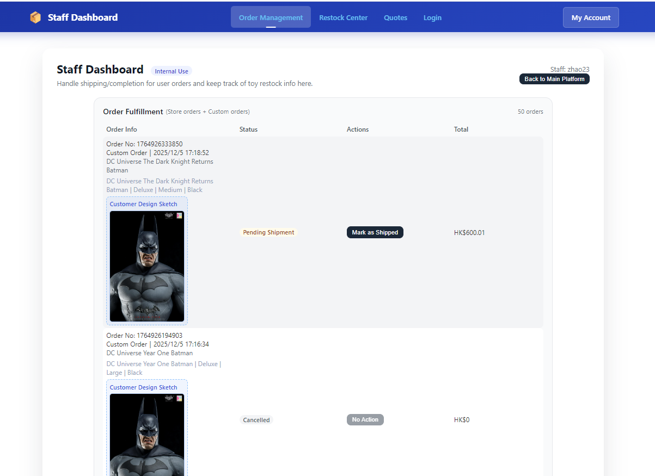
Once the customer accepts the quotation, the custom product order will be marked as "Awaiting Shipment". If the customer rejects the quotation, no further action is required for that custom order.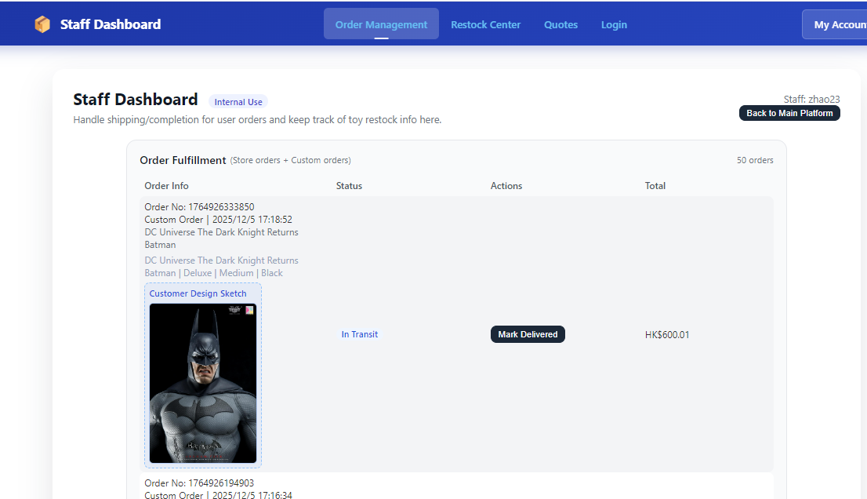
Click the "Mark as Shipped" button to confirm shipment.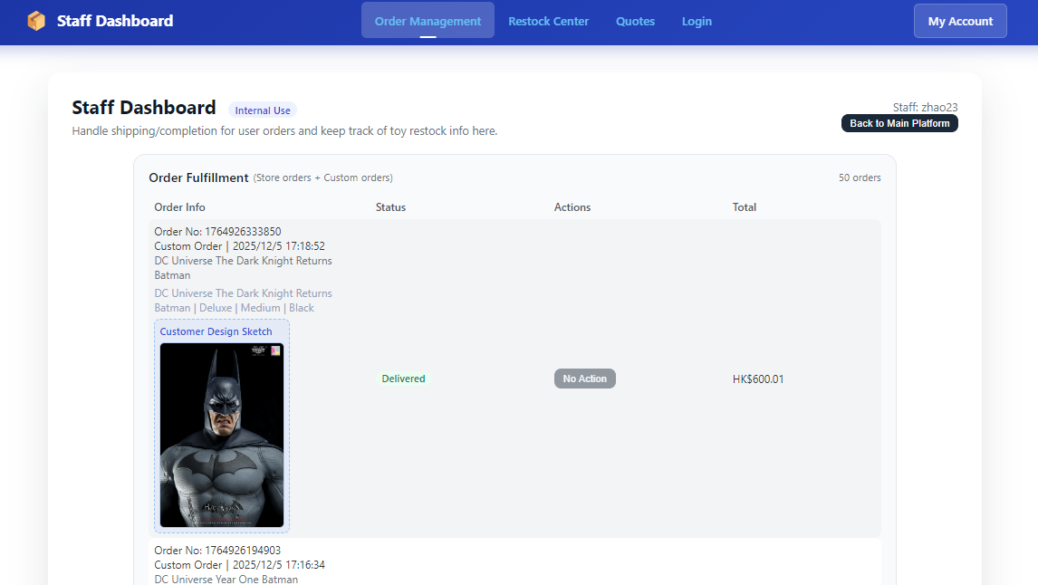
- Click the "Mark as Delivered" button. After confirming customer satisfaction, the subsequent order actions will be completed.
- Once the customer confirms receipt, the order status will show "Completed".
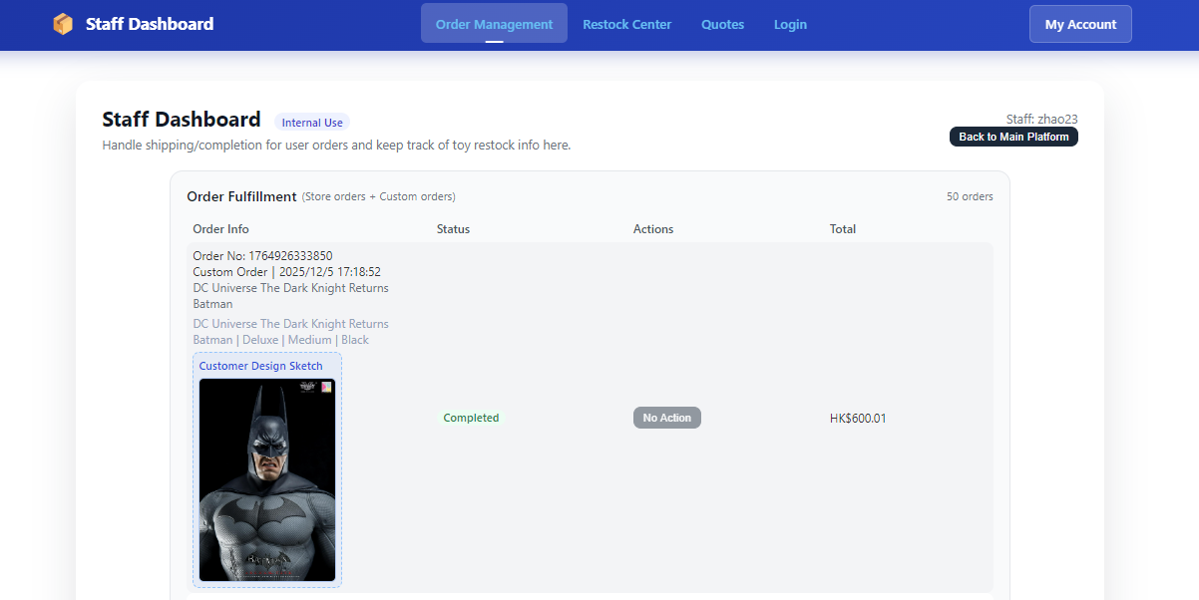

If the customer requests a refund, you can either approve the refund or reject it by selecting a rejection reason.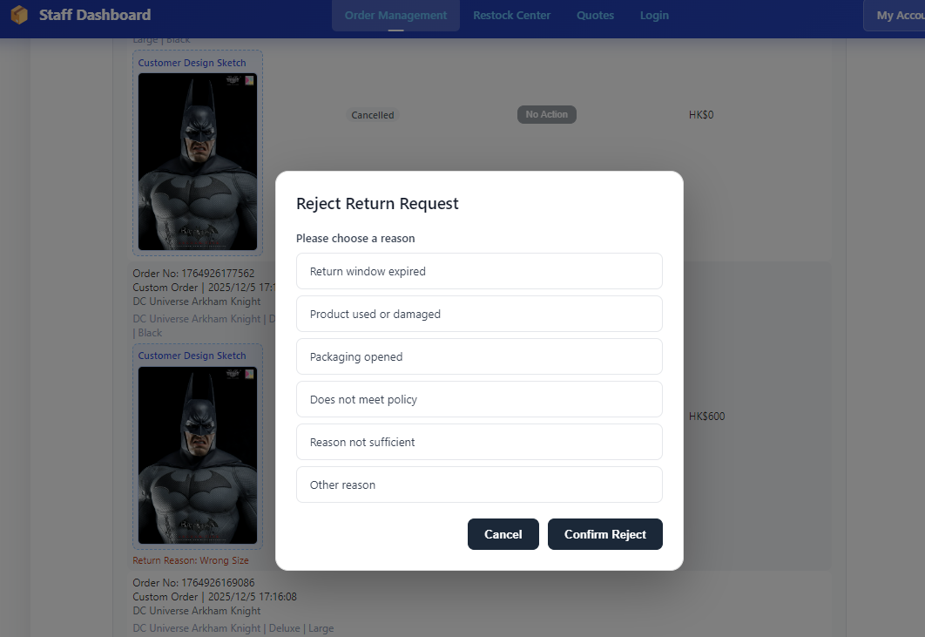
On the staff profile page, you can view and edit the staff's personal information.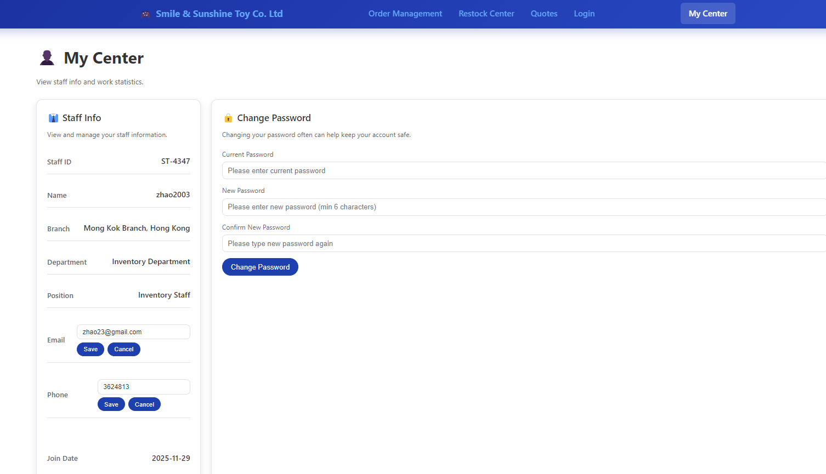
You can also view your own work status.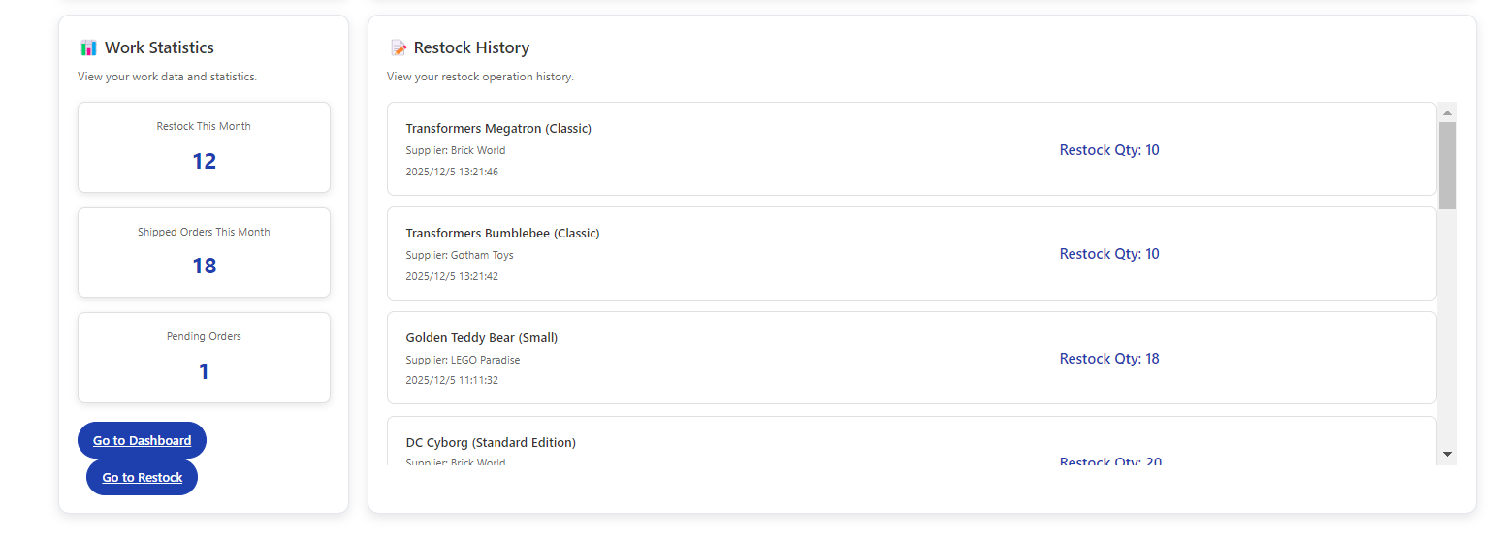
When products are out of stock, the restock page will display the out-of-stock items and remind staff that restocking is needed.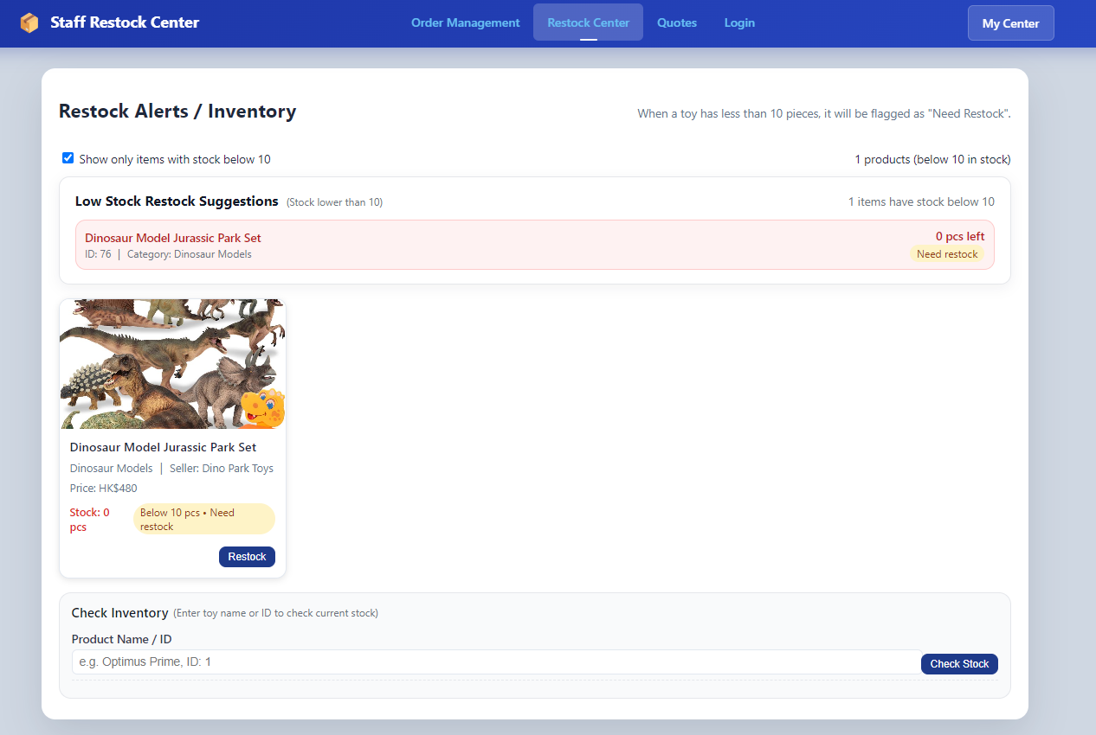
Click the "Restock" button to initiate the replenishment process.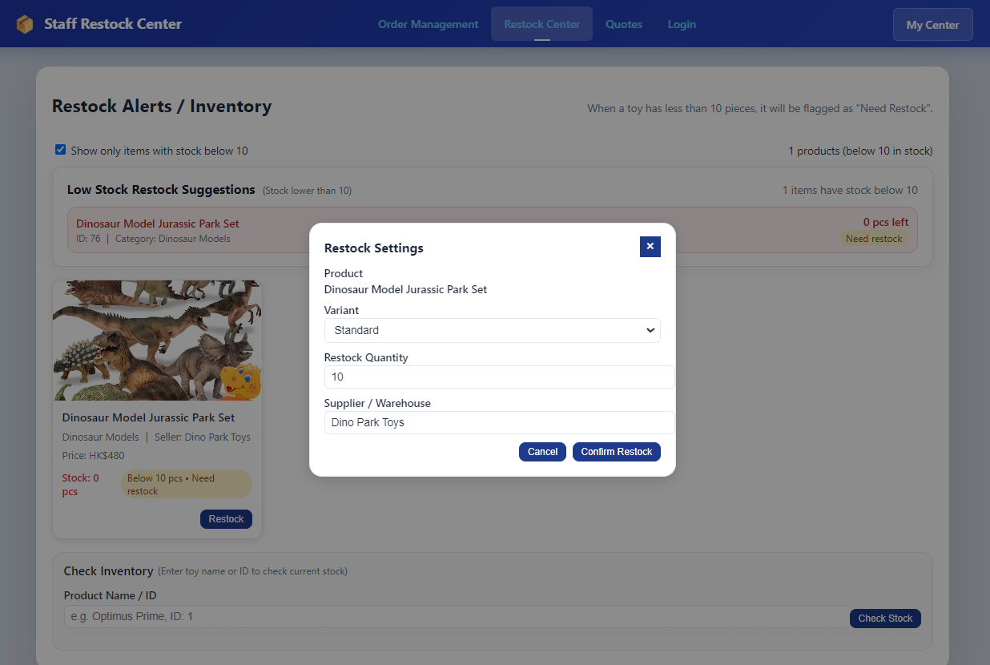
You can also check the inventory quantity of other products below.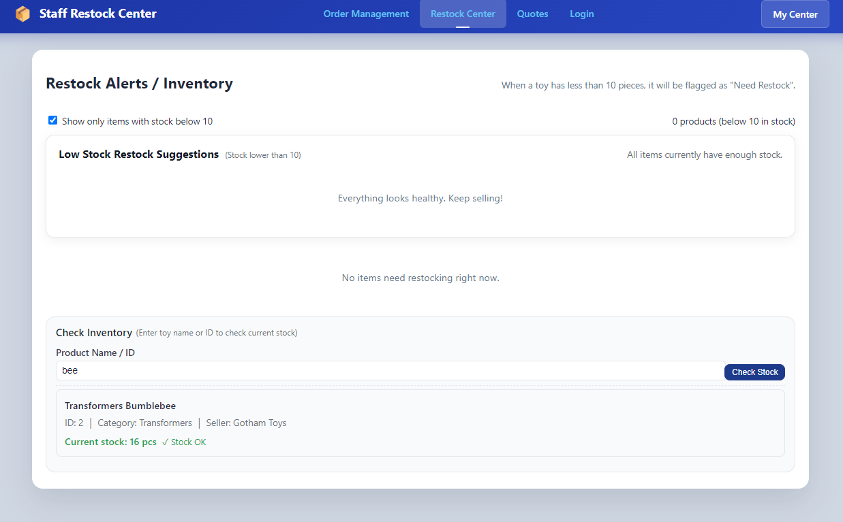
- • Sub-task Key Points: Inventory Visualization, Specification Selection, Address Selection, Payment Confirmation, Status Tracking.
- • Quotation Application (Personal Responsible Part 2)
- Enter the customization page → 2) Fill in requirements (category/specifications/color/sketch upload) → 3) Submit application → 4) View quotation history → 5) Accept/reject quotation → 6) Make payment or communicate again.
- • Sub-task Key Points: Form Validation, File Upload Usability, Status & Feedback (Pending Review/Quoting/Generated/Accepted/Rejected).
- 3. Web Design Concept (20%)
- Combine the five principles of the course with page screenshots (examples: Login, Official Store, Shopping Cart, Customization Page, Quotation History, My Orders, Staff Backend).
- • (i) Mental Model
- Follow e-commerce conventions: Top navigation, shopping cart icon, order status (Pending/Shipping/Delivered), and quotation process similar to "work orders".
- • (ii) Affordance
- Unified top navigation with explicit entries (Official Market / Toy Customization / Quote History / Wishlist / My Orders / Cart / Login).
- Clear button copy (Add to Cart, Buy Now, View Quote, Accept/Reject Quote, Request Return).
- • (iii) Content Organization
- Information partitioning: Product cards (image/name/price/inventory), order cards (product list + status + address + actions), backend cards (order/restock/quotation lists).
- Priority display of key information: Inventory, price, delivery method, status labels.
- • (iv) Visual Organization
- Color hierarchy: Primary color (blue), accent states (active pagination with black background and white text, red dots on logos), status colors (green for Delivered, orange for Pending, gray for Disabled).
- Alignment & spacing: Card-based layout, row/column alignment, dividers.
- • (v) Navigation Design
- Fixed top navigation, hover dropdown for user center; highlighted pagination and category tabs; optional breadcrumbs (e.g., backend).
- Cross-page consistency: Unified font/font size/spacing/button style/animation effects.
- User Analysis (15%)
- User Characteristics:
- List 3–4 core user roles (e.g., Parents/Gift Buyers, Toy Enthusiasts, Bulk Purchase/Corporate Clients, Internal Customer Service/Operations Staff, Warehousing/Delivery Personnel), along with their age groups, device preferences (mobile/PC), goals, and pain points.
- Observation and Listening Methods:
- Usability testing, small-scale interviews, questionnaires, customer service log analysis, A/B testing, heatmaps/clickstreams.
- Environment Analysis:
- Usage scenarios (mobile fragmented use at home, PC use in offices, PC/tablet use in warehouses), network conditions (mobile 4G/5G, WiFi), and the impact of lighting/noise on UI design.
- User Recruitment:
- Screening criteria (role/purchase frequency/customization experience), channels (in-site pop-ups, communities, emails), and incentives (coupons/gift cards).
- Task Analysis (HTA, Hierarchical Task Analysis):
- Decompose at least 2–3 key tasks, such as "Purchase In-Stock Items," "Submit Customization Requirements," "View/Accept/Reject Quotations," "After-Sales/Returns," and "Backend Shipment Processing." Use hierarchical lists or tree diagrams to show steps and decision points, and mark potential error/waiting stages.
- 3) Web Design Concept (20%)
- First, provide an overview explaining the overall design language adopted (unified navigation, card-based information presentation, color/contrast, animation feedback, accessibility).
- Then, correspond to each course principle with project screenshots for illustration:
- Mental Model: Follow common e-commerce/quotation process layouts, with button copy aligned with user language.
- Affordance: Fixed main navigation, clear status filtering, key actions (place order/submit/save/ship) as primary color buttons; loading/submission status with progress indicators or disabled states.
- Content Organization: Information grouping (product details, price breakdown, delivery/returns, quotation status), segmented forms with aligned labels, default values, and placeholder hints.
- Visual Organization: Primary color (blue) + accent colors, adequate white space, hierarchical cards, consistent font sizes/line heights, dual cues of icons + text; animations/transitions to guide visual focus.
- Navigation Design: Unified top navigation, breadcrumbs (e.g., for backend), fixed filter/search positions, responsive folding for mobile devices; current page highlighted.

